截止日期/ As of the date：2014.7.25
展商名称/ The exhibitors name |  | 展位号/ The booth no.
联系人/ The contact | 电 话/ telephone | 电子邮件/ E-mail

展位设计图/ The booth plan figure 18㎡
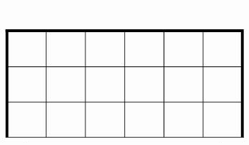
增加设施内容/ Increase content of facilities：
我单位需要增加展板 块、射灯 只，展板颜色为 色 。
I need increase unit panel , Shoot the light , Panel color 。

◆ 请在图中用粗线标明增加展板、照明灯或搭建储物间的具体位置并详细填写参展商名称（用于楣板制作），同时填写增项设施申请表，于2014年7月25日前一并发送至执委会办公室；
Please use thick line in figure marked increase panel, lighting, or structures, store between content location and fill in the names of the exhibitors and city (for lintel board word production), add item facilities form is to be completed at the same time, on July 15, 2014 shall be sent to the board office;
◆ 如无特殊搭建需求将按标准展位示意图搭建，请提前计划增加展板和射灯数量，布展开始后不再接受增加展板和射灯的申请。
If there is no special structures, demand will be effected according to the standard booth sketch, please plan ahead and increase the quantity of panel and shoot the light, after the start of the exhibition will no longer accept increase panel and shoot the light of the application.
◆ 展位效果图请参考“艺术周”官方网站。
The booth effect chart please refer to the official website "week".

